Role Of Arduino In Real World Applications

KRITI BANKA

**Abstract:**

Arduino is the physical programmable board. A wide array of sensors can be attached to this board and many third-party libraries can be linked with an Arduino sketch. Arduino hardware components are cheaper in relation to other controller architecture and programming language is easy. Arduino has greater academic applications.

**ARDUINO APPLICATIONS**

Arduino boards are playing very important roles in many disciplines today.

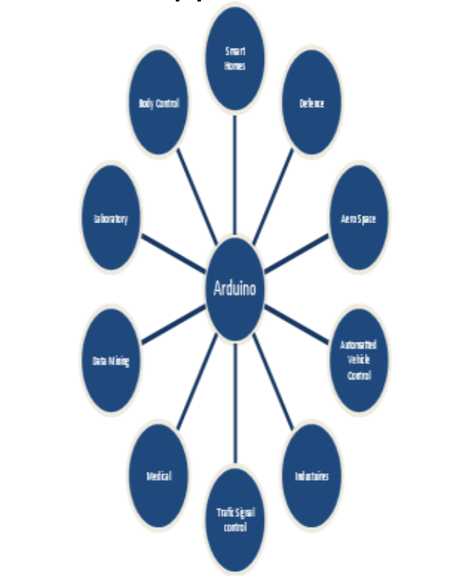

**Smart Homes**

With Arduino boards, we can control the home activities with the control systems such as motion sensors, outlet control, temperature sensors, blower control, garage door control, airflow control, sprinkler control, and bill of materials.

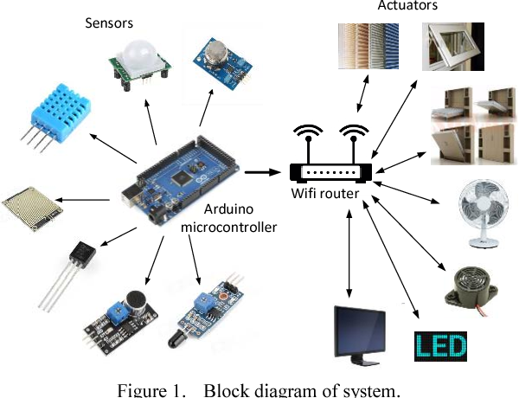

**Defense**

RADAR (Radio Detection and Ranging) is a radio wave-based object-detection system that can find out the range, altitude, direction, or speed of objects. A Radar can have different sizes and have different performance specifications]. It is used for air traffic control at airports, long-range surveillance, and early-warning systems in ships. This system is the heart of a missile guidance system. In war, a number of small portable radar systems are maintained and operated, as well as systems that occupy several large rooms

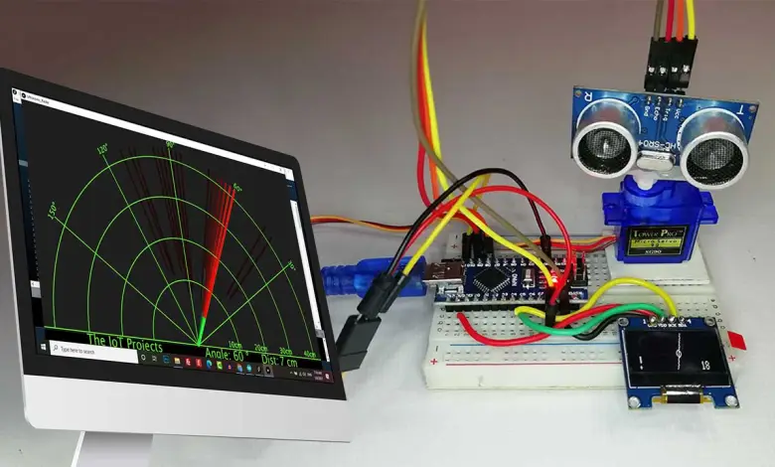

**Industries**

Due to the easy programming environment, signal types, and easy adaptation in the new setup, Arduino is used in Many industries. Arduino boards are low-cost, and flexible alternatives to the usual industrial devices for adding remote control and monitoring functionality to small legacy industrial systems. With the growth of wireless technologies such as WiFi and cloud services in the few past years, wireless systems become monotonous in our daily life.

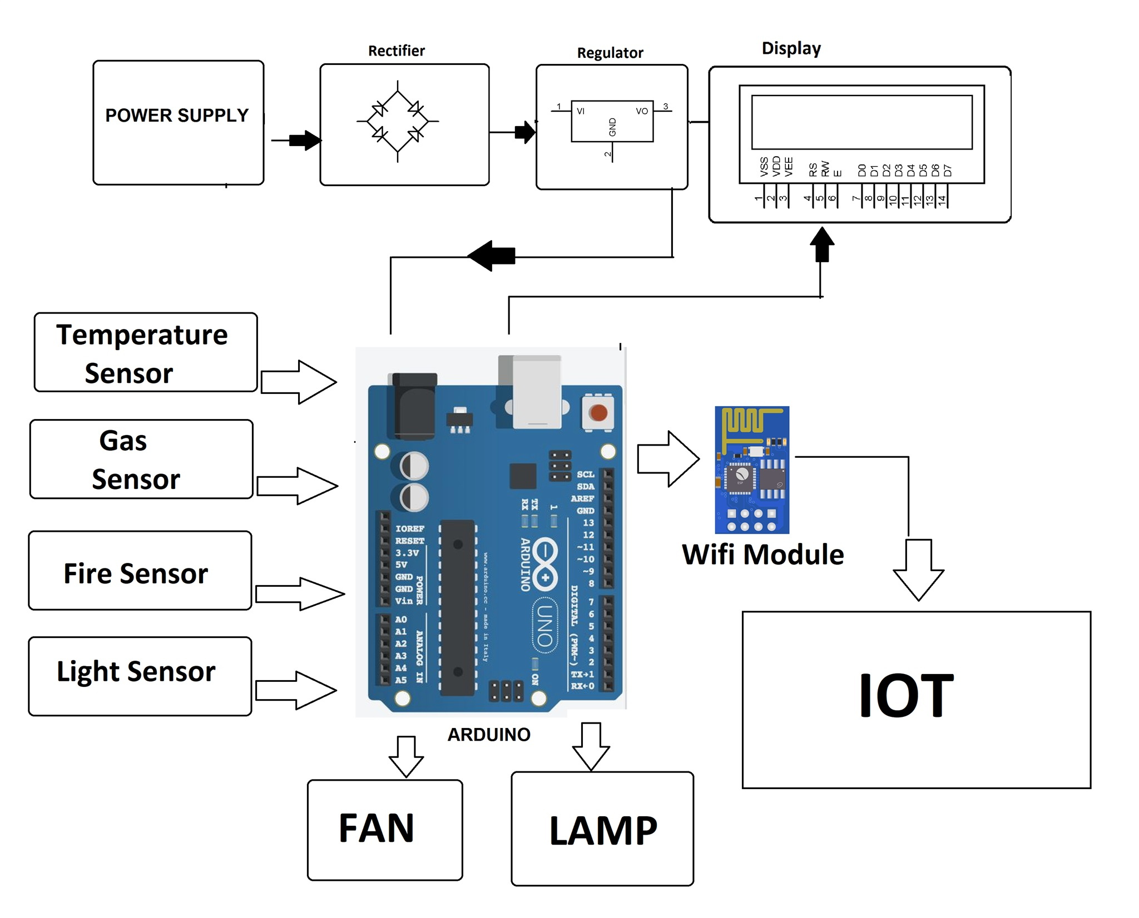

**Traffic Signal Control**

Today Arduino is used for the control of traffic lights, it can also be used for the real-time control system with programmable timings, pedestrian lighting, etc. In a traffic control system, the junction timing adjusts automatically to accommodate the movement of vehicles smoothly avoiding waiting time at the junction.

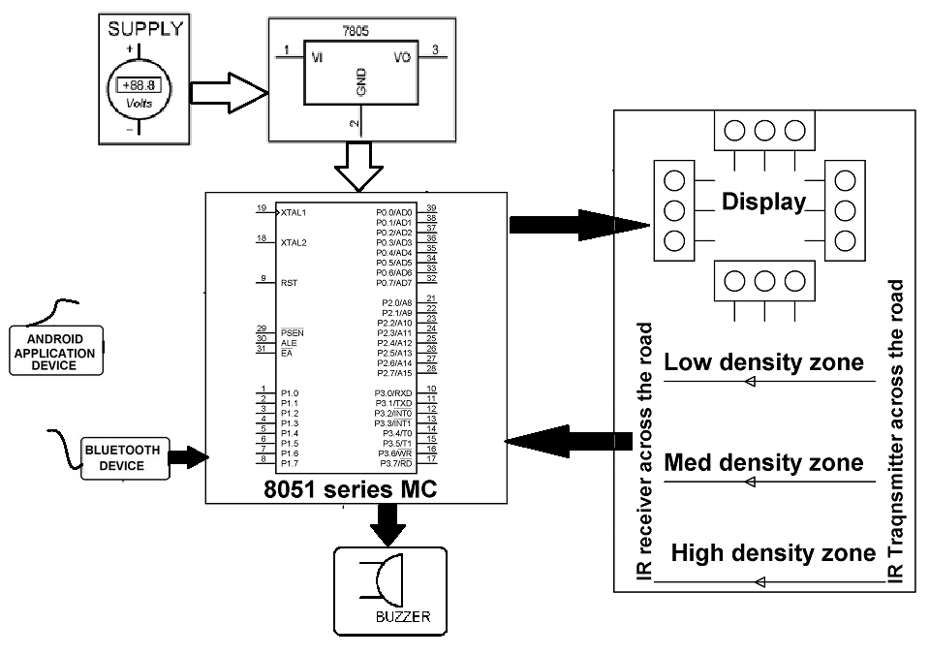

**Medical**

An Arduino-based heartbeat monitor counts the number of heartbeats in a minute. In this, a heartbeat sensor module is attached that senses the heartbeat upon putting a finger on the sensor [10]. Arduino is used for designing many medical types of equipment such as customizable Breathalyzer, little automatic slipper foot massager, Open source EEG/ECG/EMG, Thermometer, WI-Fi Body Scale with Arduino Board, etc.

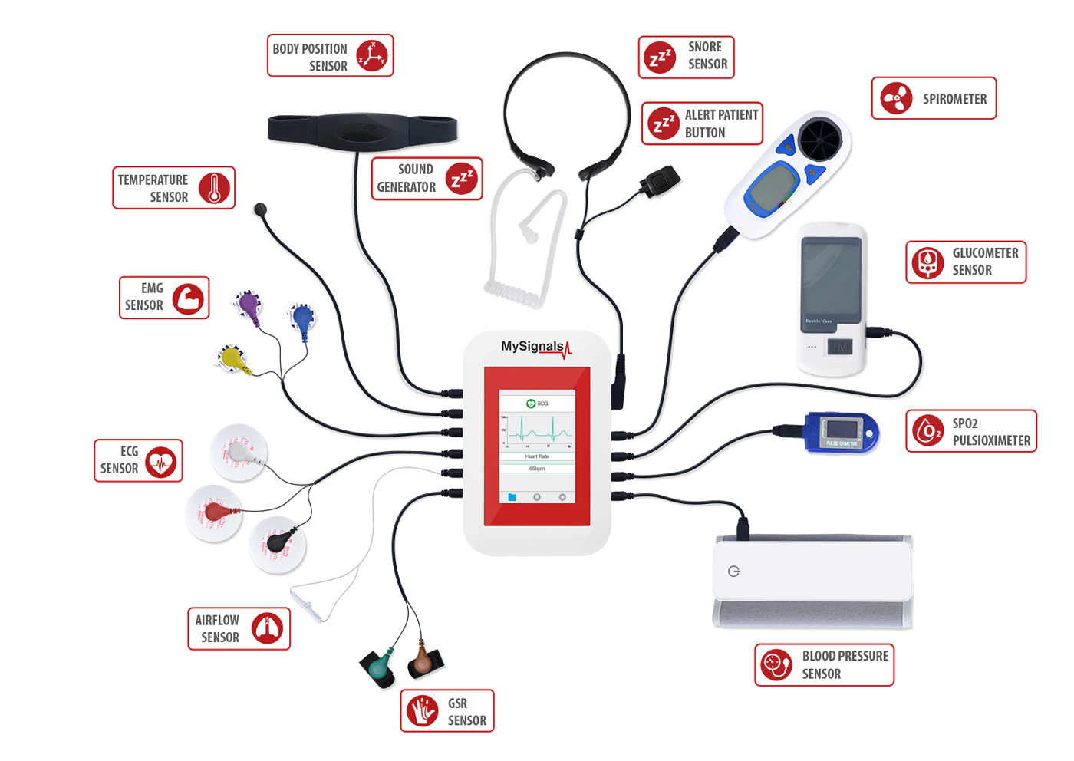

**Laboratories**

In the laboratory for the designing and learning circuit designing Arduino provides a useful platform. There may be chances of some damages or any something wrong by the beginners and it may also be costly for the students to use new electronic parts. This Arduino Simulator offers a solution to these problems, no damage done to your components, no money spends on hardware, faster circuit prototyping, and no mess with cabling at all. Arduino-based automated slide movement microscope is a very cost-effective laboratory device.

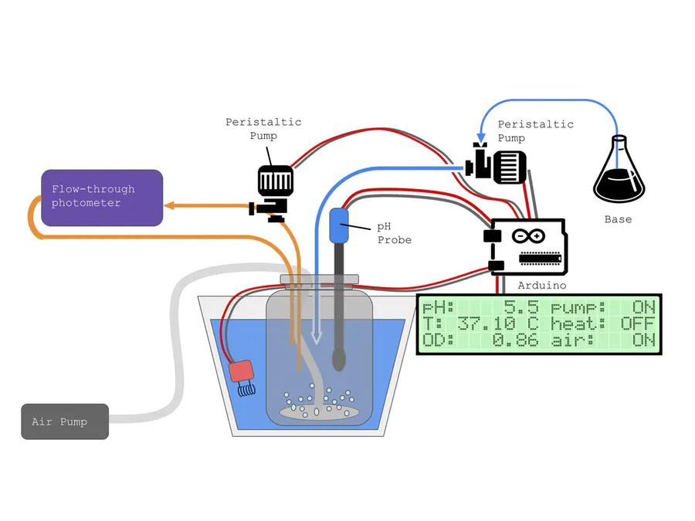

**Body Control with Arduino**

There are many body control devices with Arduino used for health care such as hindsight gloves, breathalyzer microphones, heart rate monitoring systems, etc. An Arduino-based heart rate monitor is more advanced than a simple measure of a user’s heart rate. Our heart rate monitors talks! Each button gives a verbal description of its functionality and makes the measurements visible on the screen. This monitor will save the last four readings, display them, average them, and also offer some inspirational quotes. This sensor is used for fever, hypothermia, and activity levels, and patterns detections. This device can sense facial expressions. With the help of this Arduino device, we can find out breathing rate, breathing depth, activity level, and arousal level. For movement monitoring we use this Arduino device, it can detect the occurrence of muscle contractions and strength of muscle contractions. We can check organ health and arousal and it can be used for diagnostic for medical intervention and enhance social interaction. Electrodermal Activity: Another name of this sensor is Galvanic Skin Response (GSR), used for emotional and physical arousal. Eye trackers are utilized as a part of exploration on the visual framework, in brain research, in psycholinguistics, showcasing, as an information gadget for human PC cooperation, and an item plan. In hindsight, sensors are used to sense lights, find the distance of physical objects. In the breathalyzer microphone, there is a collection of blood-alcohol content level data sets. It can also easily be adapted for karaoke.

**Aerospace**

Classical control theory to an airplane flap model and integration of RC vehicles in a Robotic Arena

**Automatic Vehicle Control**

In this blog, a testbed infrastructure designed for vehicle driving includes control-system experimentation, strategies, and sensors. These four facilities and instruments.

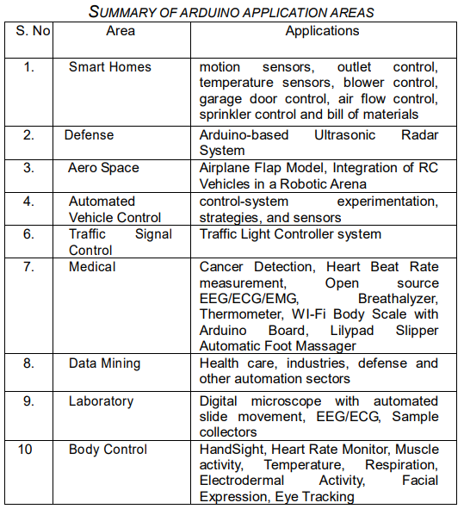

CONCLUSION

There is a number of application areas for the Arduino board, we highlight as many references as possible, however, it may also be possible that we missed out on some areas. Based on this paper, we found that this is well suited for smart homes, medical, and body control systems. It is hoped that this paper will benefit computer scientists who are keen to contribute their works to the field of automation.

Page break image